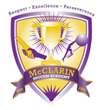Frank McClarin Success Academy
Cap and Gown Order Form

Student Name______________________________________
Home Phone_______________________________________
Cell Phone_________________________________________
Email Address______________________________________

I plan to participate in December_______May_______
I do NOT plan to participate___________

Weight ______________(as accurate as possible)
Height ______________ (ladies, add an extra inch if wearing heels.)
T-Shirt Size __________ (S, M, L, XL, XXL)

Date______________________________________________
Signature__________________________________________

